People and Places of the New Territories (year 1256)

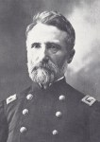Commander Herman Bowville – Born in Salem in 1218. Served uneventfully in Falleron’s Army for years before taking a commission with the Free Riders and heading west into the territories. As an officer with the Free Riders, he led many missions, protecting settlers and hunting down hostile goblin camps.

In 1253, Bowville’s unit, along with several other Free Rider companies, was present at the burning of Howland Point. The incident so affected Bowville that he resigned his commission with the intention of returning to the east. However, before leaving the Territories, he was recruited by agents of the Rangers and now oversees operations at the Citadel.

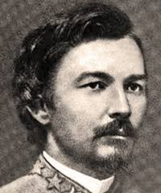

Captain Josund Stark – Born in 1216 in the settlement of Taro, Josund Stark is the charismatic and decisive leader of the largest company of Free Riders operating in the Territories. He was a contemporary of Herman Bowville and the two were said to be good friends before Bowville left the Riders.

Stark is well known in the Territories. A childhood encounter with a band of feral grunj left a powerful impression on him and he carries that onto the fields of battle where his cunning and ferocity are legendary. After the incident at Howland Point, Stark has been given a free hand (and ample cash) by the local authorities to hunt down the native tribes to make the land safer for Bostonian settlers.

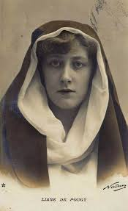Learned Sister Lillianne Semple – The descendant of a failed noble family, Sister Semple is in charge of both the physical and spiritual health of the Rangers at the Citadel. A precocious child, she was originally trained in the cloisters of Sunsrest, and the universities of Boston and Salem and was one of the youngest sisters to ever be submerged in the Dark Lake.

Lillianne survived the ritual and bound the Sacred Falls, but was granted prophetic visions and struck blind in the process. As news of her ordeal spread, many people took it as a sign that Sister Semple was blessed by the Mother and they flocked to her. The young priestess did not take well to her sudden notoriety; her health deteriorated and her behavior became erratic. In response, the Temple leadership moved her from place to place for nearly a decade, hoping to hide her from the public eye. The Citadel is her most recent posting.

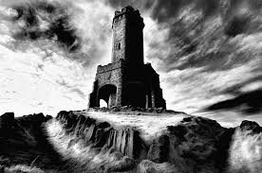The Citadel – The Citadel is the headquarters of the Rangers. It is built on the ruins of an abandoned monastery in the foothills about an hour’s ride from St. Martin. It could easily hold up to 200 troops, but as most of the Rangers spend their time in the field, the Citadel typically holds only 30-40 people. Because of its disuse, much of the building is still in poor condition.

Over the course of their travels, Ranger teams will periodically return to the Citadel to rest, train and provision themselves. In addition, pay is delivered here and stored until the agent returns to collect.

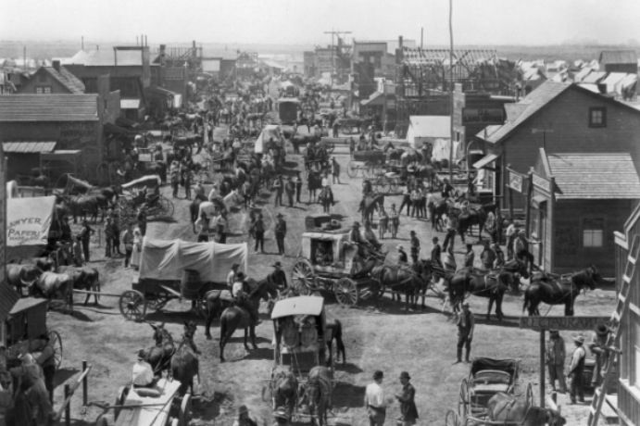St. Martin – St. Martin is a bustling rail town located on the western edge of the Thatch Mountains. It is the westernmost point of the Guild Railway and is thus a hub for travelers and trade between Bostonia and the new Territories.

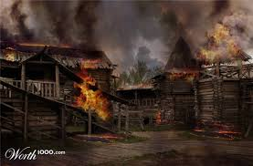

Howland Point – Howland point was a small settlement in the northern section of the Territories. In 1252, it was the site of a brutal battle between the Arakko goblins and multiple companies of Free Rider mercenaries. The goblins were driven off, but not before the town was burned and the settlers massacred.

After this event, relations between settlers and natives strained and many settlements stepped up efforts to eradicate nearby tribes. The Free Riders, led by Cpt. Josund Stark, is currently in charge of one such campaign.

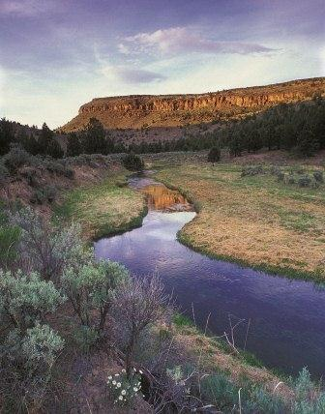The Mill – The Millicent River is a large river originating from a natural spring called Sanguine Point in the northern region of the Territories. It is remarkable because the spring had been dry for many years before being revitalized by a ritual performed by the Temple. One of the priestesses died during the ritual and the newborn river was named after her, but locals often shorten the name to “The Mill.”

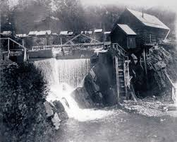Dead Horse – The town originally called White Horse is located on the Millicent River near the center of the region called the Cauldron. It was a town of farmers, herders and prospectors, but once the river dried up, it became a ghost town and folks started calling it Dead Horse.

The Millicent River is reborn now and Dead Horse is a local hub for three large ranches, numerous smaller farmsteads, a mine run by the Solomon Company and a few prospectors looking to find some of that color left behind from the city’s first heyday.

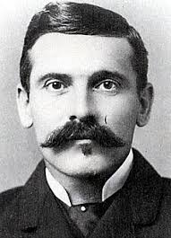Dr. Allen Engels – Dr. Engels is a scholar, chemist and inventor who operates out of the town of Dead Horse. He has a fairly successful practice, but spends nearly all of his money on his studies and parts for his inventions – which have met with only mixed success. He is a local celebrity with the children of Dead Horse because he will give them toys and oddities that he creates in his spare time.

Engels is close-lipped about his past. This, and his sudden arrival in town, have cause a few folks to wonder if the eccentric inventor has a skeleton or two in his closet.

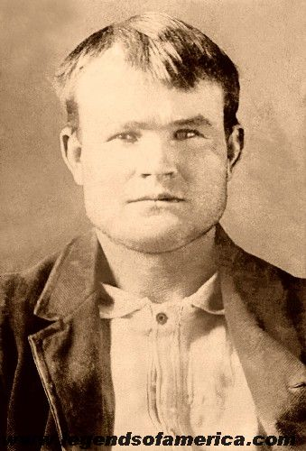

William T. Braxton – William Braxton was born in the Territories in 1233. He has run with outlaws and criminals for most of his young life and is now the head of a gang of bandits operating near Dead Horse. He is very familiar with the wilderness of the region and also of the deserts of the cobrat lands. This knowledge has allowed him to escape capture more than once.

That said, Braxton hasn’t had any great successes in his career as an outlaw. He and his gang have pulled off a few small robberies, but they have yet to cash in a big score.

Temple of the Living Blood – The Temple of Aestra in Dead Horse is named after the ritual used to bring the Millicent River back to life. The temple is run by Mother Elise, Learned Sister Delphina, and six lay priestesses. Officially, the temple is not devoted to a specific saint, but it is rumored that a secret shrine to the slain priestess is somewhere nearby.

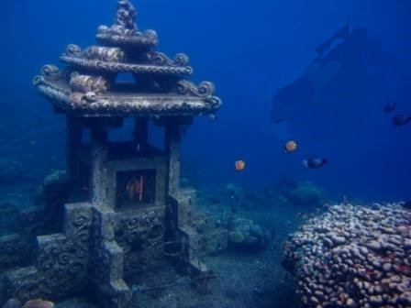The Mystery of the Underwater Temple – The story goes that when the sisters embarked on their journey to revive the Millicent River, they stumbled on a mystery. Sunken into the dried riverbed, they found a ruined shrine to Aestra. The origin of this shrine is a mystery, though some scholars have proposed that it must have been built by the early Pioneers before they crossed into the desert and met with whatever force turned them from the true religion.

Sheriff Redfork – The laconic and well-rested sheriff of Dead Horse spends most of his time rounding up drunks from the local saloons and making sure no harm comes to the status quo of his hometown. He likes to stay in town and rarely ventures forth to clear the nearby wilds of bandits or natives. Because of this, he often posts bounties for bounty hunters and mercenaries to collect. He is friendly with Rangers, though he would prefer they keep their business outside the city limits.

Deputy Able – A young, eager deputy with navigation and survival skills. He is untested in a real fight.